**A SYNOPSIS SUBMITTED**

**FOR**

**SEMINAR- PROJECT WORK (CO5G)**

**ON**

**“E Pagar book and attendance System”**

***Submitted to***

**Maharashtra State Board of Technical Education, Mumbai**

***For partial fulfillment of the***

**Diploma in Computer Engineering**

***By***

**Rohit Harshe 1801320123**

**Pratik Dahat 1801320133**

**Sumit Raut 1701320120**

**Shradha Ghagre 1701320117**

***Under the Guidance of***

**Prof. M.K Tatte**



**Department of Computer Engineering**

**Government Polytechnic, Arvi**

**2020-2021**

**SYNOPSIS**

**“E Pagar book and attendance system”**

**Introduction**

E PagarBook is a free & easy to use employee management, work & payroll management software app where you can manage all your staff and employee's attendance, record the work done by your staff and employees and their salary, payments & advances can also be recorded in this app.

E Pagar book and attendance system is an Internet-based Java application that automates the working of a company or work center that manage and maintain records of the employees in the different department.

The supervisor holds the various activities like sending notifications, mark attendance, and deleting the employees, and on the other hand employees view their details, view schedule or the notifications or any message form supervisor, and view attendance.

**Related Work:**

The objective of the E pagar Book and attendance system project in java and MYSQL is to design a salary management and attendance system for a work center. In this Project we manage the attendance of employee and salary of employee. In this project we deduct salary if the attendance is low. In salary we manage basic salary, allowances, Various taxes etc. This report documents the process of designing, building, and testing a software system to be used in a company. The piece of software, and therefore the project, is known as an “Employee Payroll Management System”. This project basically includes two modules i.e. Supervisor and Employee. The system will do the following:

**1)Admin:**

Admin can Add/Edit/delete the employees.

Admin can Add/Edit/delete the schedule the work of the employees.

Admin can Add/Edit/delete mark the attendance of employees.

Admin can Add/Edit/delete Leaves and timesheet of the employee.

Admin can Add/Edit/Delete the Salary of the employee.

**2)Employee:**

Registration according to category (developer, tester, and designer).

Employees can view his/her schedule set by Admin.

Employees can check his/her attendance.

Employees can update his/her details.

Employees can reset passwords.

Employees can View their salary.

**Proposed work & Objectives**

**Aim of the Project**

E Pagar book system is use for digitalize Company employee salary data in our system. To provide convenient way to obtain Employee salary information online rather than manual procedure. In old days these data store manually. It is very lengthy and time consuming procedure. These process have many drawback such loss of data, manual calculation , it require many pages, registers and its another problem to store such huge number of pages and register securely. That’s why we created such system which will store all information in database, take all salary information of employee with correct manner.

**Objective of project in short listed bellow:**

* Tailor made for different types of staffs. PagarBook keeps you free from headache of salary calculation.
* Mark Attendance in one click. PagarBook smartly calculates the salary based on attendance inputs considering Overtime, Late Fine, Leaves, and Half days.
* Send SMS notification for all the attendance and Payment records and share Pay slip on employee's Whatsapp number in few clicks.

**Methodology**

We think about major problem and observe, we visit the company and discuss about it and decided to create such kind of project which help to overcome the problem facing related to payment system in our society, companies, organisation.

We collect the information and try to execute our project. We divided the operation to our team member to complete it in the less time. One will collect information about hardware, one will collect information about software, and some will test the project and so on. We decided to use language Java. And use database MySQL

.

**System Requirement:**

**Hardware requirement**

In hardware requirement we require all those components will provide us the platform for the development of the project. The minimum hardware required for the development of this project is as follow-

* + - Processor : Intel P-IV system
    - Processor Speed : 250MHz to 833MHz
    - RAM : 512MB RAM
    - Hard Disk : 40GB

These all are the minimum hardware requirements required for our project. We want to make our project. To be used in any type of computer therefore we have taken minimum configuration to large extent. 128 MB RAM is used so that we can execute our project in least possible Ram. 5 GB hard disc is used because project takes less space to be executed stored. Therefore, minimum hard disc is used. Other enhancement according to the needs.

**Software Requirements**

Software’s can be defined as programs which run on our computer. It acts as petrol in a vehicle it provides the relationship between the human and the computer. It is very important to the run software to function the computer various software’s as needed in the project for its development.

* Operating System : Windows 7 / 8 / 10, Linux, IOS
* Database : MySQL
* Programming language : JAVA.
* Web-Browser : Google Chrome / Firefox / Opera / Safari

**REFERENCES:**

* Complete java reference
* <https://codebun.com/employee-payroll-management-system-project-in-java/>
* Oracle MYSQL Book
* [www.wikipedia.com](http://www.wikipedia.com)

  
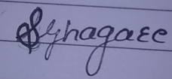



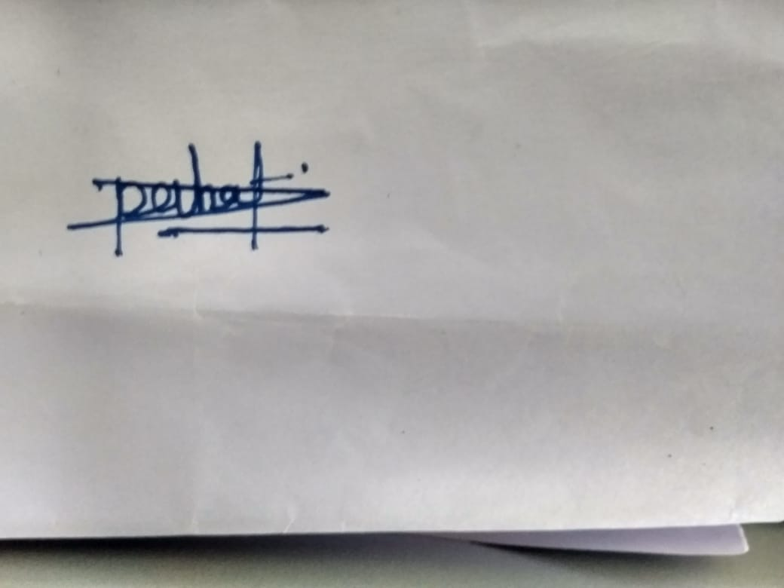

**Signature of Candidate Signature of Guide**

Prof. M.K Tatte

Rohit Harshe

Pratik Dahat

Sumit Raut

Shradha Ghagre

**Department of Computer engineering**

**Government Polytechnic, Arvi**